To use this template, make a copy by selecting FILE / MAKE A COPY to make your own Google Docs file, or FILE / DOWNLOAD to create a word doc if you’d prefer to work offline.

## **Project “Danger Dragon” 1-Page GDD**

*Brief Summary or Hook*

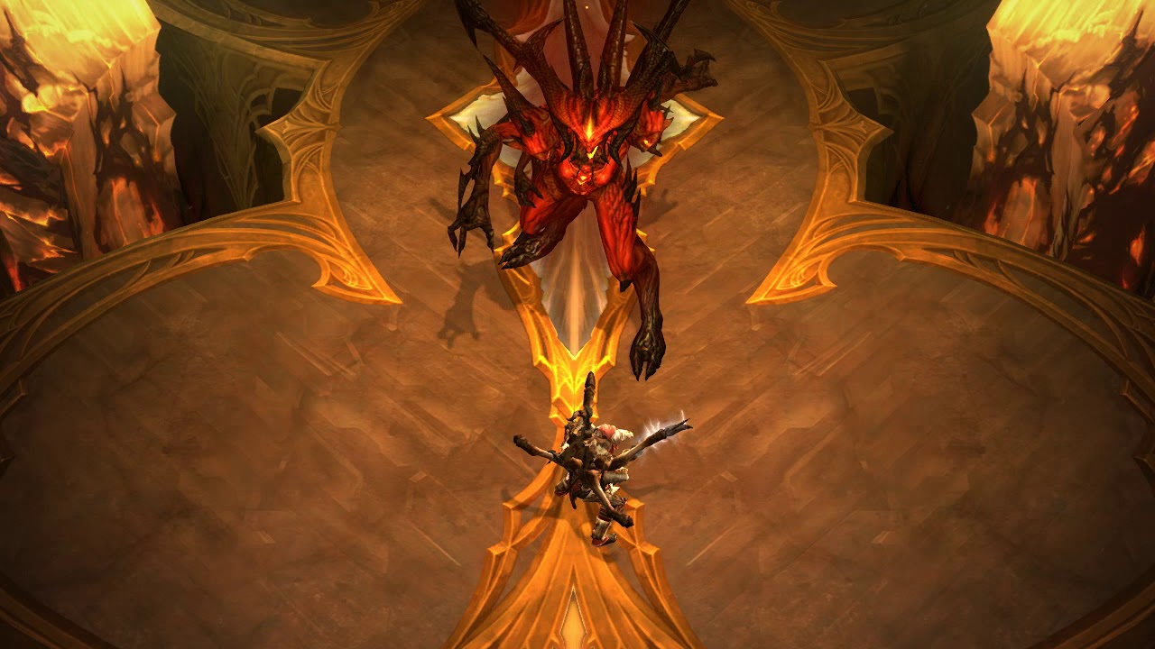

**Genre:** RPG, 3d person fixed camera.  
**Target Audience:** Teen

**Controls:** Mouse & TrackPad + keyboard or gamepad

**Thematic Setting:** Fantasy world + fantasy player person and dragon

**Tech Stack:** Unity 5+, Blender, Illustrator, Audacity

**Platform(s):** Play Market, AppStore, Steam

**MVP Game Moment:** Zone prepare to fight and zone fighting with dragon

**Game Summary:**

**Core Player Experience:**

**Central Story Theme:**

**Design Pillar:**

**Remarkability:**

**Anticipated Steam Early Access Launch date:**

**Feature Development Priorities:**

**Reference Games:**